SR | USER Requirements | GPT Results | VeriGen Results
 | The Customer clicks the log-in button on the Home Page. | 6 The system shall provide the ability to display a "Log In" button on the Home Page. | 1. The system shall provide customer with the ability to click the login button on the home page.
 | The system displays the log-in page. | 7 The system shall provide the ability to display a log-in page when the "Log In" button is clicked. | 2. The system shall be able to display the login page.
 | The customer enters his login Id with password. | 8 The system shall provide the ability to enter a login ID on the log-in page.  9 The system shall provide the ability to enter a password on the log-in page. | 3. The system shall provide customer with the ability to enter his login i d with password.
 | The customer clicks on the confirm button. | 10. The system shall provide the ability to click a "Confirm" button on the log-in page. | 4. The system shall provide customer with the ability to click on the confirm button.
 | The system checks that all of the required information was entered. | 11. The system shall be able to check if both login ID and password fields are filled when the "Confirm" button is clicked. | 5. The system shall be able to check that all of the required information entered.
 | If the entered information is wrong then system asks customer to reenter the details. | 12 If either the login ID or password field is empty, then the system shall be able to display an error message requesting all required information. | 6. If the entered information is wrong then the system shall be able to ask customer to reenter details.
 | The system validates the entered information against the tables stored in the database. | 14 The system shall be able to validate the entered login ID and password against the stored credentials in the database. | 7. The system shall be able to validate the entered information against the tables stored in the database.
 | The admin clicks the log-in button on the Home Page. | Missing | 8. The system shall provide admin with the ability to click the login button on the home page.
 | The system displays the log-in page. | Missing | 9. The system shall be able to display the login page.
 | The admin enters his login Id with password. | Missing | 10. The system shall provide admin with the ability to enter his login i d with password.
 | The admin clicks on the confirm button. | Missing | 11. The system shall provide admin with the ability to click on the confirm button.
 | The system checks that all of the required information was entered. | Missing | 12. The system shall be able to check that all of the required information entered.
 | If the entered information is wrong then system asks admin to reenter the details. | Missing | 13. If the entered information is wrong then the system shall be able to ask admin to reenter details.
 | The system validates the entered information against the tables stored in the database. | Missing | 14. The system shall be able to validate the entered information against the tables stored in the database.
 | The customer already has navigated to the main options screen. | Missing | 15. The system shall provide customer with the ability to already navigate to the main options screen.
 | The customer enters the details of source station, destination station, date to get the best possible buses. | 19 The system shall provide the ability to enter a source station on the main options screen.  20 The system shall provide the ability to enter a destination station on the main options screen.  21 The system shall provide the ability to enter a travel date on the main options screen. | 16. The system shall provide customer with the ability to enter the details of source station , destination station , date to get the best possible buses.
 | The customer also enters the type of bus he wants to book. | 22 The system shall provide the ability to select a type of bus for booking. | 17. The system shall provide customer with the ability to also enter the type of bus website wants to book.
 | Customer enters all the information- name, age, number of passengers, source station, destination station. | 23 The system shall provide the ability to enter a name for the booking.  24 The system shall provide the ability to enter age for the booking.  25 The system shall provide the ability to enter the number of passengers for the booking. | 18. The system shall provide customer with the ability to enter all the information name , age , number of passengers , source station , destination station.
 | The customer can use help facility to know how to fill the information, HelpFacility use case is carried out. | 26 The system shall provide the ability to use a help facility to get instructions on filling information.  27 The system shall be able to execute the HelpFacility use case when the help facility is used. | 19. The system shall provide customer with the ability to use help facility to know how to fill the information , helpfacility use case carried out.
 | He clicks the "Search" button. | 28 The system shall provide the ability to click a "Search" button to search for buses. | 20. The system shall be able to clicks search button.
 | If all the required information is not entered by the customer then the system highlights the blank fields to be entered. | 29 The system shall be able to check if all required fields (source station, destination station, date, bus type, name, age, number of passengers) are filled when "Search" is clicked.  30 If any required field is not filled, then the system shall be able to highlight the blank fields. | 21. If all the required information is not entered by the customer then the system shall be able to highlight blank fields to entered.
 | After searching, the System displays a list of all the buses that matches the customer’s input, each bus in the list has an associated price. | 32 The system shall be able to search for buses matching the entered criteria.  33 The system shall be able to display a list of all buses matching the search criteria.  34 The system shall be able to display the price associated with each bus in the search results. | 22. The system shall be able to display a list of all the buses that matches the customers input , each in the list has an associated price.
 | Customer selects the "Purchase Ticket" link from the list of options. | 35 The system shall provide the ability to select a "Purchase Ticket" link from the list of options. | 23. The system shall provide customer with the ability to select the purchase ticket link from the list of options.
 | The system displays a screen with an input field for a reservation number. | 36 The system shall be able to display a screen with an input field for reservation number when "Purchase Ticket" is selected. | 24. The system shall be able to display a screen with an input field for a reservation number.
 | The customer enters a reservation number. | 37 The system shall provide the ability to enter a reservation number for ticket purchase. | 25. The system shall provide customer with the ability to enter a reservation number.
 | He clicks the "Submit" button. | 38 The system shall provide the ability to click a "Submit" button after entering a reservation number. | 26. The system shall be able to clicksThe system shall be able to display the details of the reservation.
 | System displays the details of the reservation and the customer selects the "Purchase Ticket" option. | 39 The system shall be able to display the details of the reservation after a valid reservation number is submitted.  40 The system shall provide the ability to select a "Purchase Ticket" option after viewing reservation details. | 27. The system shall provide customer with the ability to select the purchase ticket option.
 | System displays a screen with input fields for: a credit card number, cardholder name, credit card expiration date. | 41 The system shall be able to display a screen with input fields for credit card number, cardholder name, and credit card expiration date. | 28. The system shall be able to display a screen with input fields for a credit card number , cardholder name , credit card expiration date.
 | Customer enters the details for the credit card number, the cardholder name , the credit card expiration date and he clicks the "Submit" button. | 42 The system shall provide the ability to enter a credit card number for payment.  43 The system shall provide the ability to enter a cardholder name for payment.  44 The system shall provide the ability to enter a credit card expiration date for payment.  45 The system shall provide the ability to click a "Submit" button after entering payment details. | 29. The system shall provide customer with the ability to enter the details for the credit card number , the cardholder name , the credit card expiration date and website clicks the submit button.
 | If customer is stuck in the process then he can use help facility to know how to fill the information, HelpFacility use case is carried out. | 50 If the customer is stuck in the process, then the system shall provide the ability to use the help facility.  51 If the help facility is used, then the system shall be able to execute the HelpFacility use case. | 30. If customer is stuck in the process then the system shall be able to use he help facility to know how to fill information , helpfacility case is carried out.
 | System displays the success message. | 53 The system shall be able to display a success message upon successful ticket purchase. | 31. The system shall be able to display the success message.
 | A reservation has already been made and customer must have successfully navigated to the main options screen. | Missing | 32. The system shall provide customer with the ability to successfully navigate to the main options screen.
 | Customer Selects the "Cancel Reservation" option. | 54 The system shall provide the ability to select a "Cancel Reservation" option from the main options screen. | 33. The system shall provide customer with the ability to select the cancel reservation option.
 | System displays a screen with an input field for a reservation number and Customer enters a reservation number and he clicks the "Submit" button. | 55 The system shall be able to display a screen with an input field for reservation number when "Cancel Reservation" is selected.  56 The system shall provide the ability to enter a reservation number for cancellation.  57 The system shall provide the ability to click a "Submit" button after entering a reservation number for cancellation. | 34. The system shall be able to display a screen with an input field for a reservation number and customer enters a reservation number and he clicks the submit button.
 | The customer can use help facility, HelpFacility use case is carried out. | 62 The system shall provide the ability to use the help facility at any point during the cancellation process.  63 The system shall be able to display a list of help facilities when the help facility is accessed. | 35. The system shall provide customer with the ability to use help facility , helpfacility use case carried out.
 | System displays the details of the reservation. | 58 The system shall be able to display the details of the reservation after a valid reservation number is submitted for cancellation. | 36. The system shall be able to display the details of the reservation.
 | Customer Selects the "Process Cancellation" option and then system displays the main options screen again. | 59 The system shall provide the ability to select a "Process Cancellation" option after viewing reservation details.  60 The system shall be able to process the cancellation of the reservation.  61 The system shall be able to display the main options screen again after successful cancellation. | 37. The system shall provide customer with the ability to select the process cancellation option and then system displays the main options screen again.
 | The website provides instructions to the customers on how to book tickets, search buses, cancel reservation. | 66 The system shall be able to provide instructions on how to book tickets.  67 The system shall be able to provide instructions on how to search for buses.  68 The system shall be able to provide instructions on how to cancel reservations. | 38. The system shall provide website with the ability to provide instructions to the customers on how to book tickets , search buses , cancel reservation.
 | The customer clicks on help facility. | Missing | 39. The system shall provide customer with the ability to click on help facility.
 | The system displays a list of facilities. | 63 The system shall be able to display a list of help facilities when the help facility is accessed. | 40. The system shall be able to display a list of facilities.
 | The customer clicks on the type of heal required. | 64 The system shall provide the ability to select the type of help required from the help facilities list. | 41. The system shall provide customer with the ability to click on the type of heal required.
 | The system shows the instructions. | 65 The system shall be able to display instructions based on the selected help type. | 42. The system shall be able to show the instructions.
 | The admin manages the bus. | 69 The system shall provide the ability for admin to manage buses from the main options screen. | 43. The system shall provide admin with the ability to manage the bus.
 | The system asks Admin whether he wants to Add Bus or Remove Bus. | 70 The system shall be able to ask the admin whether to add or remove a bus. | 44. The system shall be able to ask admin whether he wants to add bus or remove bus.
 | The Admin selects to add bus, AddBus use case is carried out. | 71 The system shall provide the ability to select "Add Bus" from the bus management options.  72 If "Add Bus" is selected, then the system shall be able to execute the AddBus use case. | 45. The system shall provide bus with the ability to carriedIf admin selects to remove bus, then the system shall be able to carry removebus use case out.
 | If Admin selects to remove bus, then RemoveBus use case is carried out. | 74 If "Remove Bus" is selected, then the system shall be able to execute the RemoveBus use case. | Missing
 | The Admin already has navigated to the main options screen. | Missing | 46. The system shall provide admin with the ability to already navigate to the main options screen.
 | The system validates the log in information. | 75 The system shall be able to validate admin login information before allowing bus management actions. | 47. The system shall be able to validate the log in information.
 | The admin selects on adding the bus. | Missing | 48. The system shall be able to adding admin selects bus.
 | The system asks admin to fill all the required information for adding a bus in the database. | 76 The system shall be able to prompt the admin to fill all required information for adding a bus. | 49. The system shall be able to ask admin to fill all the required information for adding a bus in the database.
 | The admin fills the information. | Missing | 50. The system shall provide admin with the ability to fill the information.
 | The system displays a success message on the screen. | 81 The system shall be able to display a success message upon successful addition of a bus. | 51. The system shall be able to display a success message on the screen.
 | If all the required information is not filled by Admin then the system shows an error message. | 79 If any required information for adding a bus is not filled, then the system shall be able to display an error message. | 52. If all the required information is not filled by admin then the system shall be able to show an error message.
 | The Admin already has navigated to the main options screen. | Missing | 53. The system shall provide admin with the ability to already navigate to the main options screen.
 | The system validates the log in information. | Missing | 54. The system shall be able to validate the log in information.
 | The admin selects on remove bus. | Missing | 55. The system shall be able to admin selects remove bus.
 | The system asks admin to fill all the required information for removing a bus in the database. | 82 The system shall be able to prompt the admin to fill all required information for removing a bus. | 56. The system shall be able to ask admin to fill all the required information for removing a bus in the database.
 | The admin fills all the required information. | 83 The system shall provide the ability to enter all required information for removing a bus. | 57. The system shall provide admin with the ability to fill all the required information.
 | The system displays a success message on the screen. | 87 The system shall be able to display a success message upon successful removal of a bus. | 58. The system shall be able to display a success message on the screen.
 | If all the required information is not filled by Admin then the system shows an error message. | 85 If any required information for removing a bus is not filled, then the system shall be able to display an error message. | 59. If all the required information is not filled by admin then the system shall be able to show an error message.
 |  | 13 If either the login ID or password field is empty, then the system shall be able to highlight the missing fields.
 |  | 15. If the entered login ID or password is incorrect, then the system shall be able to display an error message requesting reentry of details.
 |  | 16. If the entered login ID or password is incorrect, then the system shall be able to clear the password field for reentry.
 |  | 17. The system shall be able to grant access to the main options screen upon successful login.
 |  | 18. The system shall provide the ability to display the main options screen after successful login.
 |  | 31. If any required field is not filled, then the system shall be able to display an error message requesting completion of all fields.
 |  | 46. The system shall be able to check if all required payment fields are filled when "Submit" is clicked.
 |  | 47. If any required payment field is not filled, then the system shall be able to display an error message requesting completion of all fields.
 |  | 48. The system shall be able to validate the credit card number format.
 |  | 49. The system shall be able to validate the credit card expiration date format.
 |  | 52. The system shall be able to process the payment upon successful validation of payment details.
 |  | 73. The system shall provide the ability to select "Remove Bus" from the bus management options.
 |  | 77. The system shall provide the ability to enter all required information for adding a bus.
 |  | 78. The system shall be able to check if all required information for adding a bus is filled.
 |  | 80. If all required information for adding a bus is filled, then the system shall be able to add the bus to the database.
 |  | 84. The system shall be able to check if all required information for removing a bus is filled.
 |  | 86. If all required information for removing a bus is filled, then the system shall be able to remove the bus from the database.
 |  | 88. The system shall be able to validate admin login information before allowing bus removal actions.
 |  | 89. The system shall be able to validate admin login information before allowing bus addition actions.
 |  | 90. The system shall be able to handle invalid reservation numbers by displaying an error message.
 |  | 91. The system shall be able to handle invalid credit card numbers by displaying an error message.
 |  | 92. The system shall be able to handle expired credit cards by displaying an error message.
 |  | 93. The system shall be able to log all failed login attempts for both customers and admins.
 |  | 94. The system shall be able to lock accounts after a configurable number of failed login attempts.
 |  | 95. The system shall be able to provide feedback messages for all successful and failed operations.
 |  | 96. The system shall be able to maintain session state for logged-in users.
 |  | 97. The system shall be able to log out users upon request.
 |  | 98. The system shall be able to timeout sessions after a period of inactivity.
 |  | 99. The system shall be able to display appropriate error messages for all system errors.
 |  | 100. The system shall be able to provide navigation links to return to the main options screen from all sub-screens.
 |  | 101. The system shall be able to mask password input on the log-in page.
 |  | 102. The system shall be able to confirm successful reservation cancellations with a confirmation message.
 |  | 103. The system shall be able to confirm successful ticket purchases with a confirmation message.
 |  | 104. The system shall be able to display the current date and time on the main options screen.
 |  | 105. The system shall be able to prevent booking for past dates by validating the travel date field.

Class Diagram (GPT)

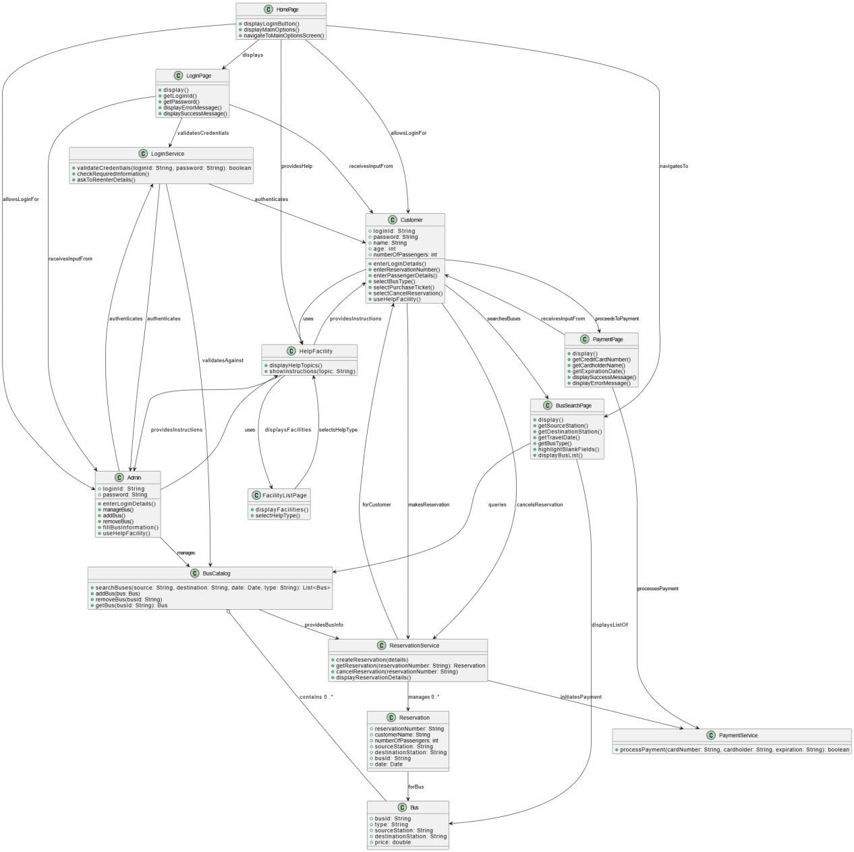

Class Diagram (VeriGen)

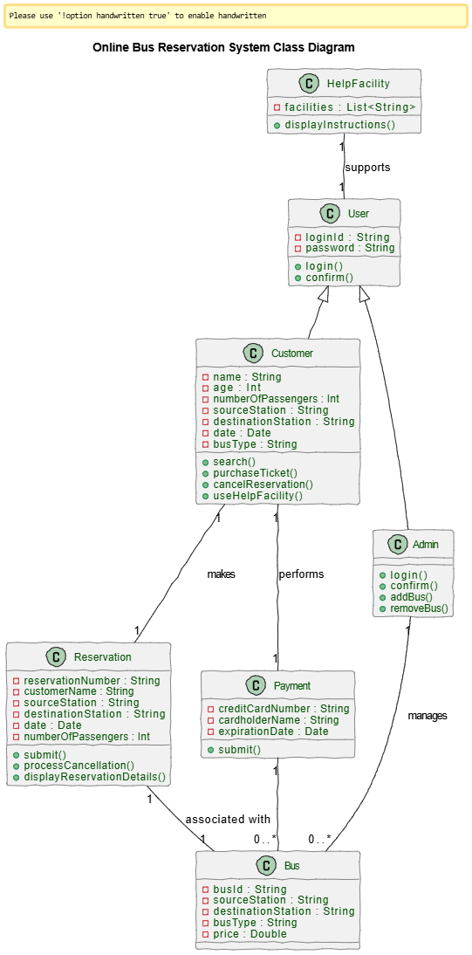

Sequence Diagram (VeriGen)

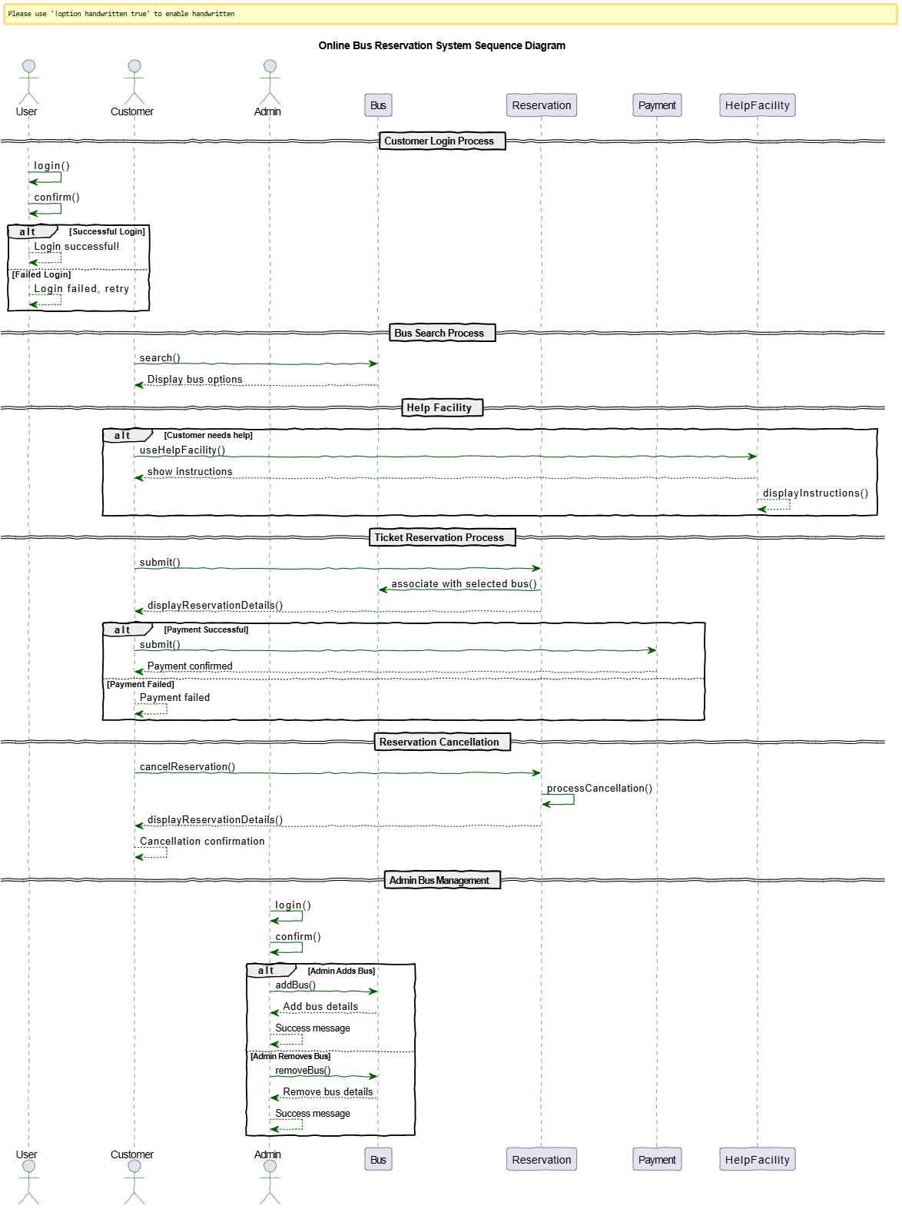

Sequence Diagram (GPT)

